Assignment no. 1

CMPE 280

HTML5 MARK-DATALIST SCORM - SCOs

**Learning Objectives:**

Mark Tag- Used alternative for mark tag to highlight text on the screen.

Math ML- Used for quant questions.

Header Tag- Used for all the pages.

Footer Tag- Used for all the pages.

Data Tag- Used for all the radio type inputs.

Video Tag- Used for displaying video in a question.

Summary Tag- Used to display summary of result.

**Login Screen:-**

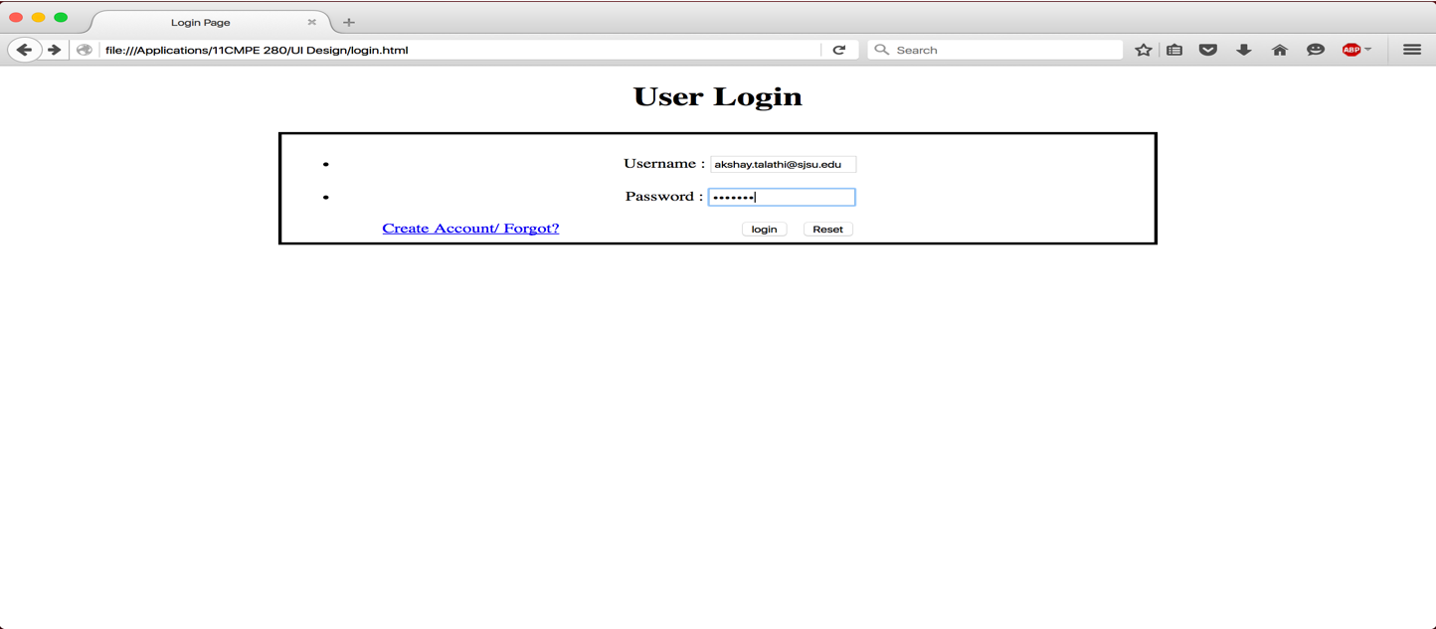

**Question 1:-**

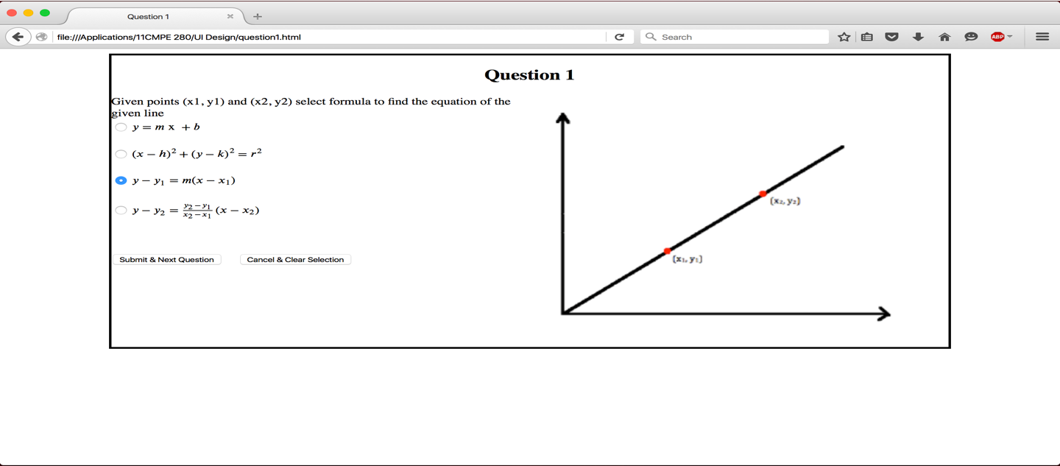

**Question 2:-**

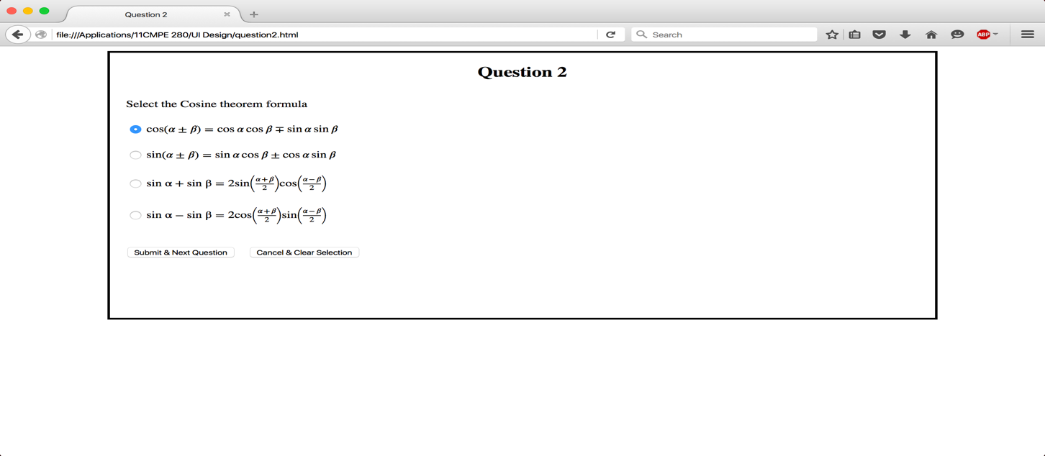

**Question 3 (highlighted text without Mark tag)**

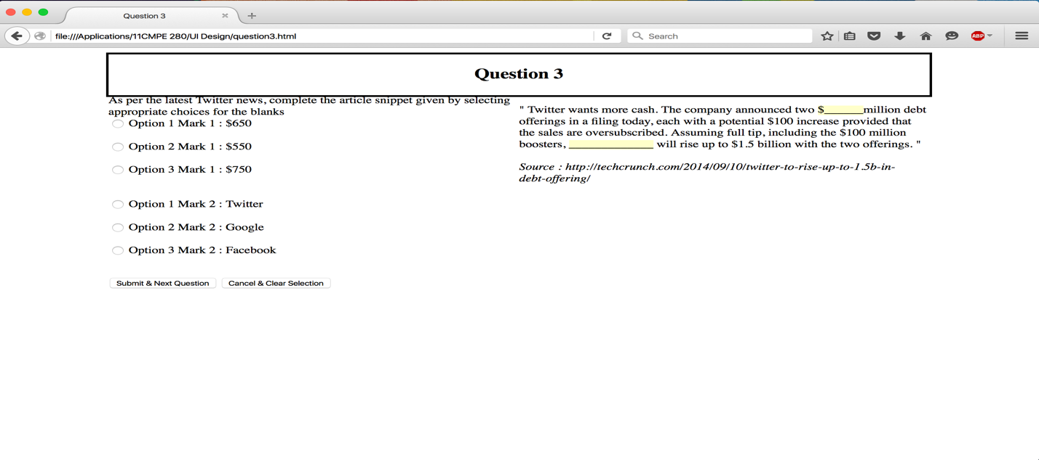

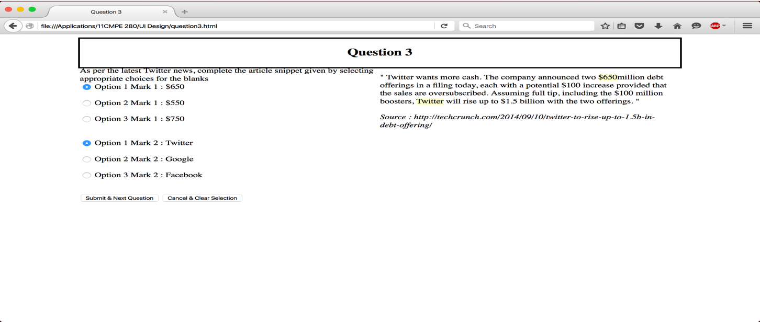

**Question 4:-**

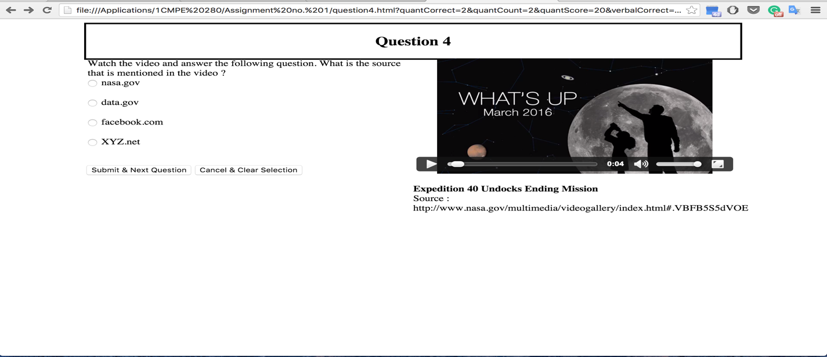

**Question 5:-**

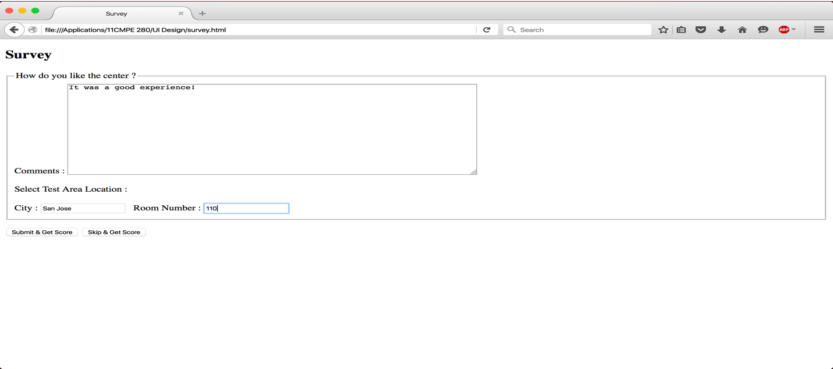

**Summary:-**

